ST. THOMAS COLLEGE, BHILAI
Training & Placement Cell
Session 2016-17
List of Students Selected in Campus Placement [2016 – 17]
Sl No | Name of Students | Stream | Name of Company | Date of Campus | Pics
01 | Amar Mishra | BCA | Capgemini | 20-12-2016 | 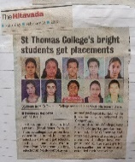
02 | P.V.Nishant Kumar | BCA
03 | Sonali Gupta | BCA
04 | Arpana Patel | B.Sc {Mathematics}
05 | Asifa Muneer | B.Sc {Mathematics}
06 | Ruby Mariam Raju | B.Sc {Mathematics}
07 | Nimita Pillai | B.Sc {Comp. Sc.}
08 | Deepa Nigam | B.Sc {Zoology}
09 | Pooja Sahu | B.Sc {Electronics}
10 | V.Rajesh | BBA | ESAF Microfinance, Nagpur | 17-01-2017 | 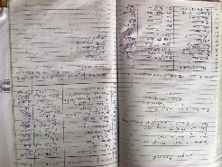
11 | AliniSoni | BBA
12 | Sajan Verma | BBA
13 | StutiGangeley | BBA
14 | Anjali Diwan | BBA
15 | Rubina John | B.Ed | J.S.P.S Memorial School, Raigarh, CG | 20-02-2017 | 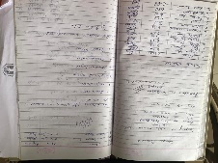
16 | Rubina John | B.Ed | Blaze Academy, Balod | 25-02-2017 | 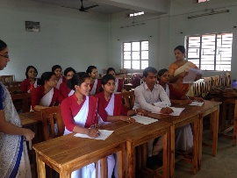
17 | Mausami Mukherjee | B.Ed
18 | Lokesh Kumar Dewangan | B.Ed
19 | Ruby Mariam Raju | B.Sc {Mathematics} | Nestle Nutrition, Mumbai | 31-01-2017 | 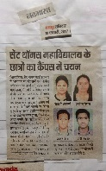
20 | Reeta Vishwakarma

