National Service Scheme
Activity Report : 2021 – 22

Date : 15, July, 2021

Activity : One day Webinar on Field Level Financial Awareness

and Literacy Programme

No. of Participants : 15

NSS Volunteers participated in One Day Webinar on Field Level Financial Awareness and Literacy Programme and got insights and basics of Financial Market Instruments and products for financial Investments
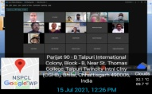

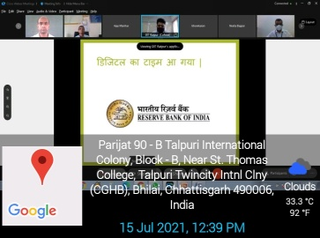

No. of students participated : 15

Sr. No. | Name of Participants | Class
1 | Bidhanshuk Dutta | B. Sc. 3rd Year
2 | Keshav Prasad Pisda | B. Sc. 3rd Year
3 | Nidhish Patel | B. Sc. 3rd Year
4 | Anjali Jha | B. A. 3rd Year
5 | Sanskriti Bhardwaj | B. A. 3rd Year
6 | Shriyanjali Panigrahi | B. A. 3rd Year
7 | Prachi Kamle | BBA 3rd Year
8 | Varsha Dhruw | BBA 3rd Year
9 | P. Pravalika | BBA 3rd Year
10 | Rahul Kori | B. Sc. 2nd Year
11 | Pushkar | B.Sc. 1st Year
12 | Tushar Pal | B.Sc. 1st Year
13 | Ayush Dewangan | BBA 3rd Year
14 | A. Govind | B. Sc. 3rd Year
15 | Shubham Kumar Sahu | B. Com. 3rd Year

P.G Department of English
Activity Report : 2021-22

Date : 17, August, 2021
Topic : Workshop on Paper Bag Making
No. of Participants : 16

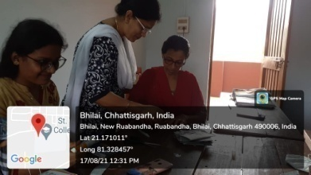
The students of B.A, St. Thomas College, Bhilai conducted a workshop on the topic “Paper Bag Making” on 17th August 2021 in Nehru Nagar Medical Store. This workshop was an active stride towards eco-friendly movement. Students were made aware them about the use of paper bags, not only as a good substitute for plastic bags but it is both recyclable and reusable. It is durable, comfortable and biodegradable.

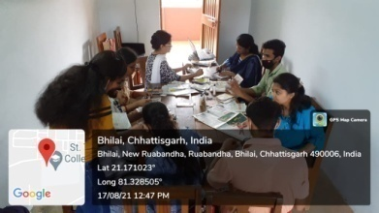

No. of Students Participated : 16

Sl. No. | Name of Participants | Class
1. | Angel Xalxo | BA – Ist Year
2. | Jeril Biju Matthews | BA – Ist Year
3. | Neha | BA – Ist Year
4. | Leeza Lowanshi | BA – Ist Year
5 | Praveen majhi | BA – Ist Year
6. | Shivani Awasthy | BA – Ist Year
7. | Simmi Chakraborty | BA – Ist Year
8. | Sukanya Anandita Jana | BA – Ist Year
9. | Yindesh Kumar Sahu | BA – Ist Year
10. | V. Priya Singh | BA – IIIrd Year
11. | Pateeksha Pandey | BA – IIIrd Year
12. | Meha Mishra | BA – IIIrd Year
13. | Chetana Dewangan | BA – IIIrd Year
14. | Harsh Kumar Yadav | BA – IIIrd Year
15. | Vibha Rani Tendon | BA – IIIrd Year
16. | Renu Dhruw | BA – IIIrd Year

P.G Department of English
Activity Report : 2021-22

Date : 20, August, 2021
Activity : Old Age Home Visit
No. of Participants : 24

The students of B.A, of St. Thomas College visited an Old Age Home at Pulgaon, Durg on 20th August 2021. Students distributed practical goods that are useful for day-to-day use. A total of 24 students participated in this program. The visit is an eye-opener for students to understand the value of time and how time will change everyone. It is also important for the students to learn bonding with elders
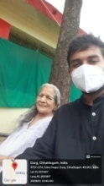
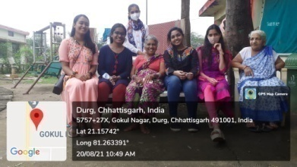

No. of Students Participated : 24

Sl. No. | Name of Participants | Class
1 | Anshika Tripathi | BA – IIIrd Year
2 | Arpita Pandey | BA – IIIrd Year
3 | Aryan Sahu | BA – IIIrd Year
4 | Aastha Ramteke | BA – IIIrd Year
5 | Jatin Ghamphoria | BA – IIIrd Year
6 | Muskaan Meghwani | BA – IIIrd Year
7 | Shireen Pagare | BA – IIIrd Year
8 | Priyanka Kaushik | BA – IIIrd Year
9 | Samita Goyal | BA – IIIrd Year
10 | Megha Merrin Mathew | BA – IIIrd Year
11 | Aashwarya Kujur | BA – IIIrd Year
12 | A. Aman | BA – IIIrd Year
13 | Patiksha Pandey | BA – IIIrd Year
14 | Kamini Kumari | BA – IIIrd Year
15 | Meha Sharma | BA – IIIrd Year
16 | Aparna Dutta | BA – IIIrd Year
17 | R. Kyati | BA – IIIrd Year
18 | Chetana Dewangan | BA – IIIrd Year
19 | Harsh Kumar Yadav | BA – IIIrd Year
20 | Sakshi Chouhan | BA – IIIrd Year
21 | Vibha Rani Tendon | BA – IIIrd Year
22 | Renu Dhruw | BA – IIIrd Year
23 | Shubham Kumar Maurya | BA – IIIrd Year
24 | Sangeet Soni | BA – IIIrd Year

National Service Scheme
Activity Report : 2021 – 22

Date : 21, August, 2021

Title : Webinar on Corona Vaccination Awareness

No. of Participants : 12

NSS volunteers participated in Online State Level NSS WEBINAR on COVID -19 Vaccination Awareness organized by Ministry of Youth Affairs and Sports regional Office Bhopal.

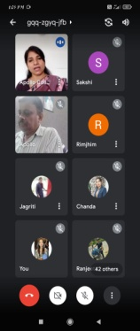

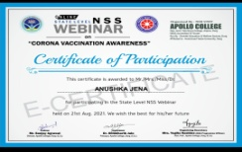

No. of Students participated : 12
Sr. No. | Name of Participants | Class
1 | Khomendra Sahu | B.Sc.1st Year
2 | Anushka Jena | BBA 3rd Year
3 | Dhananjay Yadav | B.Sc.1st Year
4 | Pushkar | B.Sc.1st Year
5 | Dhiraj | B.Sc.1st Year
6 | Abhishek Sahu | B.Sc.1st Year
7 | Komal Kariya | B. Com. 2nd Year
8 | Prachi Sahu | B. Com. 2nd Year
9 | Harshal Tekam | B. Com. 2nd Year
10 | A Govind | B. Sc. 3rd Year
11 | Keshav Prasad Pisda | B. Sc. 3rd Year
12 | Nidhish Patel | B. Sc. 3rd Year

National Service Scheme
Activity Report : 2021 – 22

Date : 20, October, 2021

Activity : Cleanliness Drive

No. of Participants : 20

NSS unit of St. Thomas College cleaned the Campus area of Government District Hospital Durg in association with Nehru Yuva Kendra Durg for Waste Management of Single use Plastic.

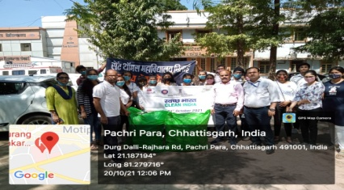

No. of Students participated : 20

Sr. No. | Name of Participants | Class
1 | Bidhanshuk Dutta | B. Sc. 3rd Year
2 | Keshav Prasad Pisda | B. Sc. 3rd Year
3 | Mandeep Bhalla | B. A. 3rd Year
4 | Tanu | B. Com. 3rd Year
5 | Sandeep Behera | B. Com. 3rd Year
6 | Riya Mandal | MSC 1st Year
7 | Prachi Sahu | B. Com 2nd Year
8 | Anshu Pandey | B. Com. 3rd Year
9 | Garima Sinha | B. Com. 2nd Year
10 | Rahul Kori | B. Sc. 2nd Year
11 | L N Shruti | B. Com. 3rd Year
12 | Hetal Chauhan | B. Com. 2nd Year
13 | Ayush Dewangan | BBA 3rd Year
14 | Khushboo Kumari | B. Com. 2nd Year
15 | Shubham Kumar Sahu | B. Com. 3rd Year
16 | Rahul Kori | B. Sc. 2nd Year
17 | Bhavini Verma | B.Com. 1st Year
18 | Harpreet Singh Arora | PGDCA
19 | Komal Karia | B. Com. 3rd Year
20 | Stutee Patra | B. Com. 2nd Year

Department of Education
Activity Report : 2021-22

Date : 21, November, 2021
Venue : Blood Bank, District Hospital, Durg
No. of Participants : 01

On 21st November2021, as a part of Community Development Programme Sudhakar Rao student of B. Ed donated blood at Blood Bank, District Hospital, Durg. The number of beneficiaries was01 student.

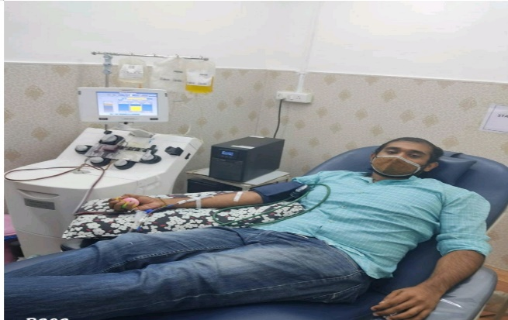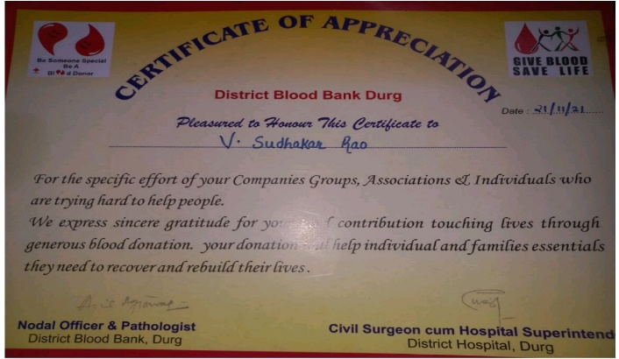

S. No | Name of Participant
1. | Sudhakar Rao

National Service Scheme
Activity Report : 2021 – 22

Date : 11, December, 2021

Activity : UNICEF Blue Brigade

No. of Participants : 33

NSS volunteers conducted field level survey for creating awareness from the prevention against COVID – 19 in village Ruabandha under Second Phase of UNICEF BLUE BRIGADE ACTIVITY.

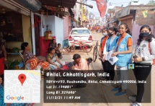

No. of Students participated : 33

Sr. No. | Name of Participants | Class | Sr. No. | Name of Participants | Class
1 | Bidhanshuk Dutta | B. Sc. 3rd Year | 17 | Purwasha Surojiya | BBA 3rd Year
2 | Keshav Prasad Pisda | B. Sc. 3rd Year | 18 | Harpreet Singh Arora | PGDCA
3 | Aneesha Khurana | B. Com. 2nd Year | 19 | Mandeep Bhalla | BA 3rd Year
4 | Anjali Jha | B. A. 3rd Year | 20 | Stutee Patra | B. Com. 2nd Year
5 | Sanskriti Bhardwaj | B. A. 3rd Year | 21 | Khomendra Sahu | B.Sc.1st Year
6 | D. Karthikeyan | B. Com. 3rd Year | 22 | Tikendra Sahu | B.Sc.1st Year
7 | Prachi Kamle | BBA 3rd Year | 23 | Dhananjay Yadav | B.Sc.1st Year
8 | Varsha Dhruw | BBA 3rd Year | 24 | Pushkar | B.Sc.1st Year
9 | Garima Sinha | B. Com. 2nd Year | 25 | Dhiraj | B.Sc.1st Year
10 | Rahul Kori | B. Sc. 2nd Year | 26 | Abhishek Sahu | B.Sc.1st Year
11 | Pushkar | B.Sc. 1st Year | 27 | Komal Kariya | B. Com. 2nd Year
12 | Hetal Chauhan | B. Com. 2nd Year | 28 | Prachi Sahu | B. Com. 2nd Year
13 | Ayush Dewangan | BBA 3rd Year | 29 | Harshal Tekam | B. Com. 2nd Year
14 | Khushboo Kumari | B. Com. 2nd Year | 30 | A Govind | B. Sc. 3rd Year
15 | Shubham Kumar Sahu | B. Com. 3rd Year | 31 | Keshav Prasad Pisda | B. Sc. 3rd Year
16 | Rahul Kori | B. Sc. 2nd Year | 32 | Nidhish Patel | B. Sc. 3rd Year
 |  |  | 33 | Hemakshi Sonwani | B. Com. 2nd Year

National Service Scheme
Activity Report : 2021 – 22

Date : 18, December, 2021

Activity : UNICEF Blue Brigade

No. of Participants : 34

NSS volunteers conducted field level survey for creating awareness from the prevention against COVID – 19 in village BORSI under Second Phase of UNICEF BLUE BRIGADE ACTIVITY.

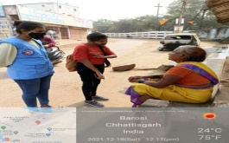
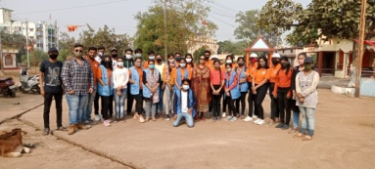

No. of students participated : 34

Sr. No. | Name of Participants | Class | Sr. No. | Name of Participants | Class
1 | Bidhanshuk Dutta | B. Sc. 3rd Year | 18 | Harpreet Singh Arora | PGDCA
2 | Keshav Prasad Pisda | B. Sc. 3rd Year | 19 | Mandeep Bhalla | BA 3rd Year
3 | Aneesha Khurana | B. Com. 2nd Year | 20 | Stutee Patra | B. Com. 2nd Year
4 | Anjali Jha | B. A. 3rd Year | 21 | Khomendra Sahu | B.Sc.1st Year
5 | Sanskriti Bhardwaj | B. A. 3rd Year | 22 | Tikendra Sahu | B.Sc.1st Year
6 | D. Karthikeyan | B. Com. 3rd Year | 23 | Dhananjay Yadav | B.Sc.1st Year
7 | Prachi Kamle | BBA 3rd Year | 24 | Pushkar | B.Sc.1st Year
8 | Varsha Dhruw | BBA 3rd Year | 25 | Dhiraj | B.Sc.1st Year
9 | Garima Sinha | B. Com. 2nd Year | 26 | Abhishek Sahu | B.Sc.1st Year
10 | Rahul Kori | B. Sc. 2nd Year | 27 | Komal Kariya | B. Com. 2nd Year
11 | Pushkar | B.Sc. 1st Year | 28 | Prachi Sahu | B. Com. 2nd Year
12 | Hetal Chauhan | B. Com. 2nd Year | 29 | Harshal Tekam | B. Com. 2nd Year
13 | Ayush Dewangan | BBA 3rd Year | 30 | A Govind | B. Sc. 3rd Year
14 | Khushboo Kumari | B. Com. 2nd Year | 31 | Keshav Prasad Pisda | B. Sc. 3rd Year
15 | Shubham Kumar Sahu | B. Com. 3rd Year | 32 | Nidhish Patel | B. Sc. 3rd Year
16 | Rahul Kori | B. Sc. 2nd Year | 33 | Hemakshi Sonwani | B. Com. 2nd Year
17 | Purwasha Surojiya | BBA 3rd Year | 34 | Dimple Netam | B. Com. 1st Year

National Service Scheme
Activity Report : 2021 – 22

Date : 31, December, 2021

Activity : Awareness Program Fundamental Duties of Constitution

No. of Participants : 36

NSS volunteers created awareness about Fundamental Duties of Constitution at Village – Hanoda in association with Hemchand Yadav Vishvavidyalaya, Durg.

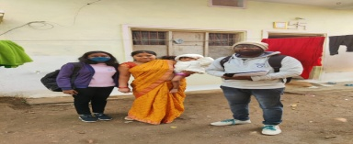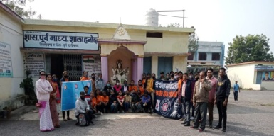

No. of students participated : 36

Sr. No. | Name of Participants | Class | Sr. No. | Name of Participants | Class
1 | Bidhanshuk Dutta | B. Sc. 3rd Year | 19 | Harpreet Singh Arora | PGDCA
2 | Keshav Prasad Pisda | B. Sc. 3rd Year | 20 | Mandeep Bhalla | BA 3rd Year
3 | Aneesha Khurana | B. Com. 2nd Year | 21 | Stutee Patra | B. Com. 2nd Year
4 | Anjali Jha | B. A. 3rd Year | 22 | Khomendra Sahu | B.Sc.1st Year
5 | Sanskriti Bhardwaj | B. A. 3rd Year | 23 | Tikendra Sahu | B.Sc.1st Year
6 | D. Karthikeyan | B. Com. 3rd Year | 24 | Dhananjay Yadav | B.Sc.1st Year
7 | Prachi Kamle | BBA 3rd Year | 25 | Pushkar | B.Sc.1st Year
8 | Varsha Dhruw | BBA 3rd Year | 26 | Dhiraj | B.Sc.1st Year
9 | Garima Sinha | B. Com. 2nd Year | 27 | Abhishek Sahu | B.Sc.1st Year
10 | Rahul Kori | B. Sc. 2nd Year | 28 | Komal Kariya | B. Com. 2nd Year
11 | Pushkar | B.Sc. 1st Year | 29 | Prachi Sahu | B. Com. 2nd Year
12 | Hetal Chauhan | B. Com. 2nd Year | 30 | Harshal Tekam | B. Com. 2nd Year
13 | Ayush Dewangan | BBA 3rd Year | 31 | A Govind | B. Sc. 3rd Year
14 | Khushboo Kumari | B. Com. 2nd Year | 32 | Keshav Prasad Pisda | B. Sc. 3rd Year
15 | Shubham Kumar Sahu | B. Com. 3rd Year | 33 | Nidhish Patel | B. Sc. 3rd Year
16 | Rahul Kori | B. Sc. 2nd Year | 34 | Hemakshi Sonwani | B. Com. 2nd Year
17 | Purwasha Surojiya | BBA 3rd Year | 35 | Dimple Netam | B. Com. 1st Year
18 | Rahul Kori | B.Sc.2nd Year | 36 | Sanskriti Bhardwaj | BA 3rd Year

National Service Scheme

Activity Report : 2021 – 22

Date : 04, January, 2022

Activity : Covid Awareness, Session on Good Touch and Band Touch

No. of Participants : 50

NSS volunteers of St. Thomas College, Bhilai conducted Rally in village Hanoda for Good Touch and Band Touch for Children and BETI BACHAO BETI PADHAO.

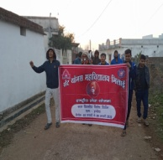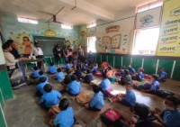

No. of students participated : 50

Sr. No. | Name of Participants | Class | Sr. No. | Name of Participants | Class
1 | Ayush Dewangan | BBA 3rd Year | 26 | V. Sonali | BBA 3rd Year
2 | Keshav Prasad Pisda | B.Sc. 3rd Year | 27 | Anjali Jha | BA 3rd Year
3 | Rahul Kori | B.Sc.2nd Year | 28 | Sanskriti Bhardwaj | BA 3rd Year
4 | Nidhish Kiran Patel | B.Sc. 3rd Year | 29 | Prachi Sahu | B.Com 2nd Year
5 | Tushar Pal | B.Sc. 1st Year | 30 | Harshal Tekam | B.Com 2nd Year
6 | Yash Belchandan | B.Com 3rd Year | 31 | Khushboo Kumari | B.Com 2nd Year
7 | Tikendra Sahu | B.Sc. 1st Year | 32 | Garima Sinha | B.Com 2nd Year
8 | Sandeep Kumar Behera | B.Com 3rd Year | 33 | Stutee Patra | B.Com 2nd Year
9 | Shubham Kumar Sahu | B.Com 3rd Year | 34 | Aneesha Khurana | B.Com 2nd Year
10 | Khomendra Sahu | B.Sc. 1st Year | 35 | Praprti Chandrakar | B.Com 2nd Year
11 | Dhananjay Yadav | B.Sc. 1st Year | 36 | Chanchal Sahu | B.Sc.2nd Year
12 | Yash Kumar Sahu | B.Com. 1st Year | 37 | Pragya Sahu | B.Sc.2nd Year
13 | Anshu Pandey | B.Com 3rd Year | 38 | Priyanka Singh | B.Sc. 3rd Year
14 | A Govind | B.Sc. 3rd Year | 39 | Emilia Kujur | B.Sc.2nd Year
15 | Joel Jose | B.Sc. 3rd Year | 40 | Sarswati Khatri | B.Sc. 1st Year
16 | Pushkar Sahu | B.Sc. 1st Year | 41 | Bhavini Verma | B.Com. 1st Year
17 | Bidhanshuk Dutta | B.Sc. 3rd Year | 42 | Disha Diwan | B.Com. 1st Year
18 | Anushka Jena | BBA 3rd Year | 43 | Roshni Dhankar | B.Sc.2nd Year
19 | Amisha Sen | B.Sc. 3rd Year | 44 | Sukanya Jena | BA 2nd Year
20 | Varsha Dhruw | BBA 3rd Year | 45 | Tanu | B.Com 3rd Year
21 | Purwasha Surojiya | BBA 3rd Year | 46 | Shriya Santosh | B.Com. 1st Year
22 | P. Pravalika | BBA 3rd Year | 47 | Himakshi Sonwani | B.Com 2nd Year
23 | Tulsi Chandra | B.Sc.2nd Year | 48 | Smruti Rekha Sahu | B.Com 2nd Year
24 | Prachi Kamle | BBA 3rd Year | 49 | Ansha Bhardwaj | BA 3rd Year
25 | Shriyanjali Panigrahi | BA 3rd Year | 50 | Dimple Netam | B.Com. 1st Year

Department of Psychology
Activity Report : 2021 - 22

Date : 05, January, 2022
Event : Physical Mental –Health And Hygiene Awareness Program
Place : Govt. Primary School, Hanoda, Durg
No. of Participants : 32 Students of School + 15 Students of STC

The students of M.A Psychology SEM II and SEM IV participated in the promotion of Mental Health and Hygeine by giving lecture and distributing toothpaste and brush.

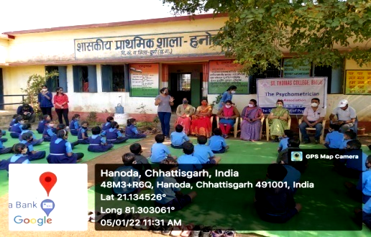

No. of Students Participated : 15

S.No | Name of Participants | Class
 | G.Priyanka | M A Sem IV
 | Sanchana sahu | M A Sem IV
 | P I Akansha | M A Sem IV
 | Bhawna Verma | M A Sem IV
 | Versha | M A Sem IV
 | Jacob Jossi | M A Sem IV
 | Meghraj Sahu | M A Sem II
 | Palak Agrawal | M A Sem II
 | Deepak Chandak | M A Sem II
 | Rohan Alex | M A Sem II
 | Aman Rajput | M A Sem IV
 | Vanshika | M A Sem IV
 | Megha Merin | M A Sem II
 | Sudhir Verma | M A Sem II
 | Upasana Verma | M A Sem II

National Service Scheme
Activity Report : 2021 – 22

Date : 05, January, 2022

Activity : Physical and Mental Hygiene

No. of Participants : 50

NSS volunteers conducted an event of Physical and Mental Hygiene in association with Dept. of Psychology. NSS Alumini Jeshal Gohil took Interactive Session of NSS volunteers.

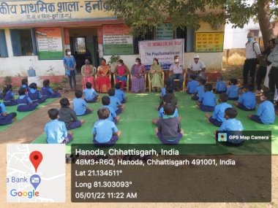

No. of students participated : 50

Sr. No. | Name of Participants | Class | Sr. No. | Name of Participants | Class
1 | Ayush Dewangan | BBA 3rd Year | 26 | V. Sonali | BBA 3rd Year
2 | Keshav Prasad Pisda | B.Sc. 3rd Year | 27 | Anjali Jha | BA 3rd Year
3 | Rahul Kori | B.Sc.2nd Year | 28 | Sanskriti Bhardwaj | BA 3rd Year
4 | Nidhish Kiran Patel | B.Sc. 3rd Year | 29 | Prachi Sahu | B.Com 2nd Year
5 | Tushar Pal | B.Sc. 1st Year | 30 | Harshal Tekam | B.Com 2nd Year
6 | Yash Belchandan | B.Com 3rd Year | 31 | Khushboo Kumari | B.Com 2nd Year
7 | Tikendra Sahu | B.Sc. 1st Year | 32 | Garima Sinha | B.Com 2nd Year
8 | Sandeep Kumar Behera | B.Com 3rd Year | 33 | Stutee Patra | B.Com 2nd Year
9 | Shubham Kumar Sahu | B.Com 3rd Year | 34 | Aneesha Khurana | B.Com 2nd Year
10 | Khomendra Sahu | B.Sc. 1st Year | 35 | Praprti Chandrakar | B.Com 2nd Year
11 | Dhananjay Yadav | B.Sc. 1st Year | 36 | Chanchal Sahu | B.Sc.2nd Year
12 | Yash Kumar Sahu | B.Com. 1st Year | 37 | Pragya Sahu | B.Sc.2nd Year
13 | Anshu Pandey | B.Com 3rd Year | 38 | Priyanka Singh | B.Sc. 3rd Year
14 | A Govind | B.Sc. 3rd Year | 39 | Emilia Kujur | B.Sc.2nd Year
15 | Joel Jose | B.Sc. 3rd Year | 40 | Sarswati Khatri | B.Sc. 1st Year
16 | Pushkar Sahu | B.Sc. 1st Year | 41 | Bhavini Verma | B.Com. 1st Year
17 | Bidhanshuk Dutta | B.Sc. 3rd Year | 42 | Disha Diwan | B.Com. 1st Year
18 | Anushka Jena | BBA 3rd Year | 43 | Roshni Dhankar | B.Sc.2nd Year
19 | Amisha Sen | B.Sc. 3rd Year | 44 | Sukanya Jena | BA 2nd Year
20 | Varsha Dhruw | BBA 3rd Year | 45 | Tanu | B.Com 3rd Year
21 | Purwasha Surojiya | BBA 3rd Year | 46 | Shriya Santosh | B.Com. 1st Year
22 | P. Pravalika | BBA 3rd Year | 47 | Himakshi Sonwani | B.Com 2nd Year
23 | Tulsi Chandra | B.Sc.2nd Year | 48 | Smruti Rekha Sahu | B.Com 2nd Year
24 | Prachi Kamle | BBA 3rd Year | 49 | Ansha Bhardwaj | BA 3rd Year
25 | Shriyanjali Panigrahi | BA 3rd Year | 50 | Dimple Netam | B.Com. 1st Year

National Service Scheme
Activity Report : 2021 – 22

Date : 06, January, 2022

Activity : Cleanliness Drive

No. of Participants : 50

NSS volunteers cleaned the compound area of Primary School at Hanoda and conducted fun and mind game activities for the students of Middle School at village Hanoda.

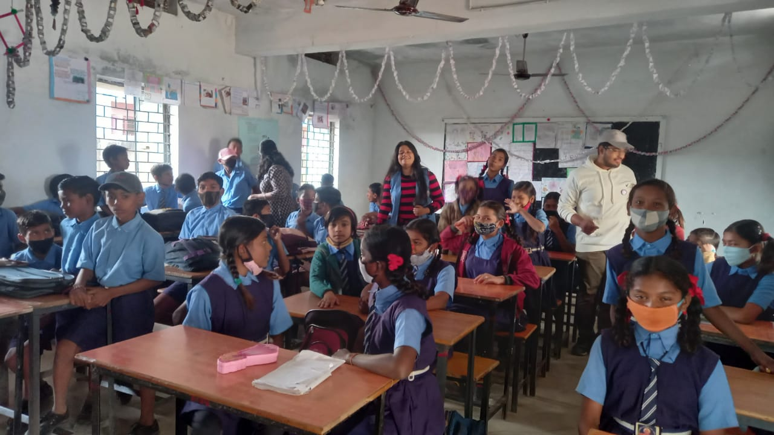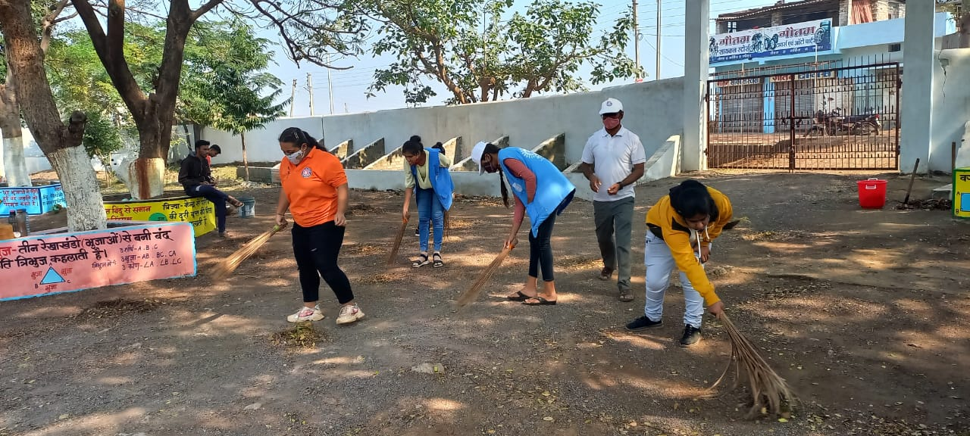

No. of students participated : 50

Sr. No. | Name of Participants | Class | Sr. No. | Name of Participants | Class
1 | Ayush Dewangan | BBA 3rd Year | 26 | V. Sonali | BBA 3rd Year
2 | Keshav Prasad Pisda | B.Sc. 3rd Year | 27 | Anjali Jha | BA 3rd Year
3 | Rahul Kori | B.Sc.2nd Year | 28 | Sanskriti Bhardwaj | BA 3rd Year
4 | Nidhish Kiran Patel | B.Sc. 3rd Year | 29 | Prachi Sahu | B.Com 2nd Year
5 | Tushar Pal | B.Sc. 1st Year | 30 | Harshal Tekam | B.Com 2nd Year
6 | Yash Belchandan | B.Com 3rd Year | 31 | Khushboo Kumari | B.Com 2nd Year
7 | Tikendra Sahu | B.Sc. 1st Year | 32 | Garima Sinha | B.Com 2nd Year
8 | Sandeep Kumar Behera | B.Com 3rd Year | 33 | Stutee Patra | B.Com 2nd Year
9 | Shubham Kumar Sahu | B.Com 3rd Year | 34 | Aneesha Khurana | B.Com 2nd Year
10 | Khomendra Sahu | B.Sc. 1st Year | 35 | Praprti Chandrakar | B.Com 2nd Year
11 | Dhananjay Yadav | B.Sc. 1st Year | 36 | Chanchal Sahu | B.Sc.2nd Year
12 | Yash Kumar Sahu | B.Com. 1st Year | 37 | Pragya Sahu | B.Sc.2nd Year
13 | Anshu Pandey | B.Com 3rd Year | 38 | Priyanka Singh | B.Sc. 3rd Year
14 | A Govind | B.Sc. 3rd Year | 39 | Emilia Kujur | B.Sc.2nd Year
15 | Joel Jose | B.Sc. 3rd Year | 40 | Sarswati Khatri | B.Sc. 1st Year
16 | Pushkar Sahu | B.Sc. 1st Year | 41 | Bhavini Verma | B.Com. 1st Year
17 | Bidhanshuk Dutta | B.Sc. 3rd Year | 42 | Disha Diwan | B.Com. 1st Year
18 | Anushka Jena | BBA 3rd Year | 43 | Roshni Dhankar | B.Sc.2nd Year
19 | Amisha Sen | B.Sc. 3rd Year | 44 | Sukanya Jena | BA 2nd Year
20 | Varsha Dhruw | BBA 3rd Year | 45 | Tanu | B.Com 3rd Year
21 | Purwasha Surojiya | BBA 3rd Year | 46 | Shriya Santosh | B.Com. 1st Year
22 | P. Pravalika | BBA 3rd Year | 47 | Himakshi Sonwani | B.Com 2nd Year
23 | Tulsi Chandra | B.Sc.2nd Year | 48 | Smruti Rekha Sahu | B.Com 2nd Year
24 | Prachi Kamle | BBA 3rd Year | 49 | Ansha Bhardwaj | BA 3rd Year
25 | Shriyanjali Panigrahi | BA 3rd Year | 50 | Dimple Netam | B.Com. 1st Year
Department of Education
Activity Report : 2021-22

Date : 06, January, 2022.
Venue : World Vision English Medium School, Balrampur
No. of Participants : 01

On 6th February 2022, as a part of Community Development Programme, Anita Murum, Student of B.Ed. Sem-I, rendered her services in a school of remote area (World Vision English Medium School). She taught physical exercises to the school students.

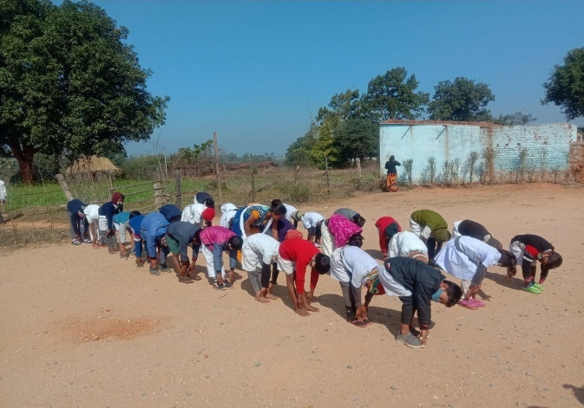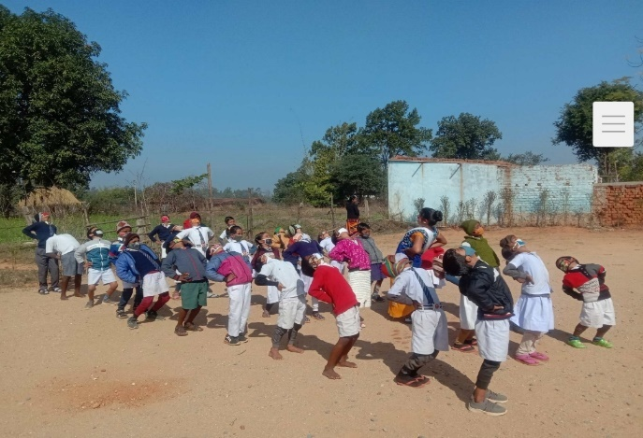

S. No | Name of Participant
1. | Anita Murum

National Service Scheme
Activity Report : 2021 – 22

Date : 07, January, 2022

Activity : Cleanliness activity

No. of Participants : 50

NSS volunteers cleaned the compound area of Primary School at Hanoda and did painting in school premises and stand of Flag Hosting Area.

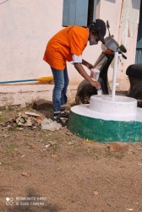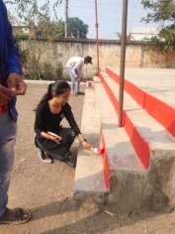

No. of students participated : 50

Sr. No. | Name of Participants | Class | Sr. No. | Name of Participants | Class
1 | Ayush Dewangan | BBA 3rd Year | 26 | V. Sonali | BBA 3rd Year
2 | Keshav Prasad Pisda | B.Sc. 3rd Year | 27 | Anjali Jha | BA 3rd Year
3 | Rahul Kori | B.Sc.2nd Year | 28 | Sanskriti Bhardwaj | BA 3rd Year
4 | Nidhish Kiran Patel | B.Sc. 3rd Year | 29 | Prachi Sahu | B.Com 2nd Year
5 | Tushar Pal | B.Sc. 1st Year | 30 | Harshal Tekam | B.Com 2nd Year
6 | Yash Belchandan | B.Com 3rd Year | 31 | Khushboo Kumari | B.Com 2nd Year
7 | Tikendra Sahu | B.Sc. 1st Year | 32 | Garima Sinha | B.Com 2nd Year
8 | Sandeep Kumar Behera | B.Com 3rd Year | 33 | Stutee Patra | B.Com 2nd Year
9 | Shubham Kumar Sahu | B.Com 3rd Year | 34 | Aneesha Khurana | B.Com 2nd Year
10 | Khomendra Sahu | B.Sc. 1st Year | 35 | Praprti Chandrakar | B.Com 2nd Year
11 | Dhananjay Yadav | B.Sc. 1st Year | 36 | Chanchal Sahu | B.Sc.2nd Year
12 | Yash Kumar Sahu | B.Com. 1st Year | 37 | Pragya Sahu | B.Sc.2nd Year
13 | Anshu Pandey | B.Com 3rd Year | 38 | Priyanka Singh | B.Sc. 3rd Year
14 | A Govind | B.Sc. 3rd Year | 39 | Emilia Kujur | B.Sc.2nd Year
15 | Joel Jose | B.Sc. 3rd Year | 40 | Sarswati Khatri | B.Sc. 1st Year
16 | Pushkar Sahu | B.Sc. 1st Year | 41 | Bhavini Verma | B.Com. 1st Year
17 | Bidhanshuk Dutta | B.Sc. 3rd Year | 42 | Disha Diwan | B.Com. 1st Year
18 | Anushka Jena | BBA 3rd Year | 43 | Roshni Dhankar | B.Sc.2nd Year
19 | Amisha Sen | B.Sc. 3rd Year | 44 | Sukanya Jena | BA 2nd Year
20 | Varsha Dhruw | BBA 3rd Year | 45 | Tanu | B.Com 3rd Year
21 | Purwasha Surojiya | BBA 3rd Year | 46 | Shriya Santosh | B.Com. 1st Year
22 | P. Pravalika | BBA 3rd Year | 47 | Himakshi Sonwani | B.Com 2nd Year
23 | Tulsi Chandra | B.Sc.2nd Year | 48 | Smruti Rekha Sahu | B.Com 2nd Year
24 | Prachi Kamle | BBA 3rd Year | 49 | Ansha Bhardwaj | BA 3rd Year
25 | Shriyanjali Panigrahi | BA 3rd Year | 50 | Dimple Netam | B.Com. 1st Year

Department of Education
Activity Report : 2021-22

Date : 09, January, 2022
Venue : JLN Hospital, Hospital Sector, (CG), Station Road (Raipur, Bilaspur)
No. of Participants : 10

On 9th January 2022, Community Development Programme was organised by the Department of Education, St.Thomas College,,Bhilai. .The venue of the programme was JLN Hospital, Hospital Sector, (CG), Station Road (Raipur, Bilaspur). As part of the community service food packets were distributed to the needy people.
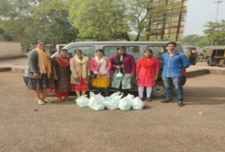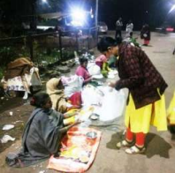
S. No. | Name of Participants | S. No. | Name of Participants
1 | Jaiby Elsa Chacko | 6 | Madhusmitha Sahu
2 | Aman Sharma | 7 | Manisha Jatwar
3 | Almma Toppo | 8 | Megha Thomas
4 | Babisha P John | 9 | Milcah George
5 | Bobby Sajan | 10 | Sneha B Mathew

Department of Education
Activity Report : 2021-22

Date : 09, January, 2022
Venue : Rajeev Nagar Ward No. 2, Ruabandha Talab, Durg.
No. of Participants : 12

On 09th January, 2022, Community Development Programme was organised by the Department of Education, St.Thomas College, Bhilai. The Venue of the programme was Rajeev Nagar Ward No. 2, Ruabandha Talab, Durg. As a part of community activity, the students of B. Ed formed a team to visit nearby area for tree plantation. The number of beneficiaries were 12 students.
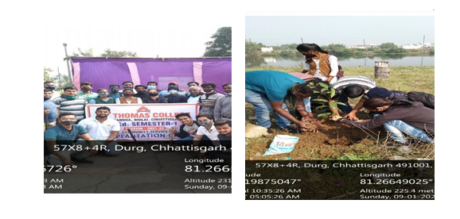
S. No | Name of Participants | S. No | Name of Participants
1 | Pradeep Tirkey | 7 | Sushma Mishra
2 | SumitT irkey | 8 | Saurabh Sao
3 | T. Vishal Bobby | 9 | Arun Kumar Lakra
4 | Soumya Sahu | 10 | Aman Prince Khujur
5 | Manjeet Khujur | 11 | Beena Minj
6 | Vijay Kumar | 12 | Mahima Tirkey

Department of Education
Activity Report : 2021-22

Date : 12, January, 2022
Venue : Risali Sector, Sector- 5 & 7, Ruabandha, Forest Avenue, Boria
Gate, Maroda Sector, Civic Centre and Subhash Nagar, Durg.
No. of Participants : 19
On12th January 2022, Community Development Programme was organised by the Department of Education, St.Thomas College, Bhilai. The venue of the programme was Risali Sector, Sector- 5 & 7, Ruabandha, Forest Avenue, Boria Gate, Maroda Sector, Civic Centre and Subhash Nagar, Durg,,C.G. .As part of community activity, the group decided to distribute Face-Shields and Masks to the Roadside Vendors. The number of beneficiaries were 19 students.

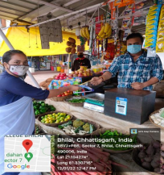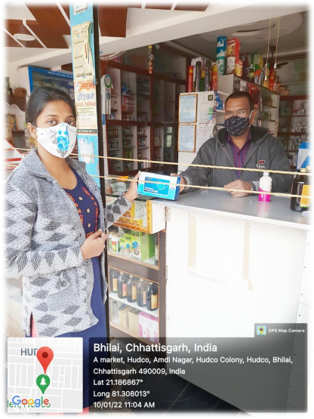

S. No | Name of Participants | S.No | Name of Participants
1 | Merina Elizer | 11 | T.R. Sweety
2 | Ananya Tiwari | 12 | Ritu Nayak
3 | Vibhuti Rana | 13 | Neelam Bhoi
4 | Sevantika Gaikwad | 14 | Neha Sahu
5 | Vazra Meshram | 15 | Ankita Kannurkar
6 | Rimmi Kumari | 16 | S. Kusum
7 | Komal Kriti | 17 | Shruti Upadhyaya
8 | Rehnuma Tarannum | 18 | Anshika Tiwari
9 | Maheshwari | 19 | Madhulika Gangber
10 | Roshni Biswas
Department of Education
Activity Report : 2021-22

Date : 15, January, 2022
Venue : In front of Jawaharlal Nehru Hospital, Sector- 9, Bhilai.
No. of Participants : 16
On 15th January 2022, Community Development Programme was organised by the Department of Education, St.Thomas College,Bhilai. The venue of the programme was Infront of Jawaharlal Nehru Hospital, Sector- 9, Bhilai. As a part of community activity, the group decided to distribute mask and sanitizer to the needy people in front of Jawaharlal Nehru Hospital, Sector-9, Bhilai. They also distributed some packets of food to those people as a token of love. The number of beneficiaries were 16 students.
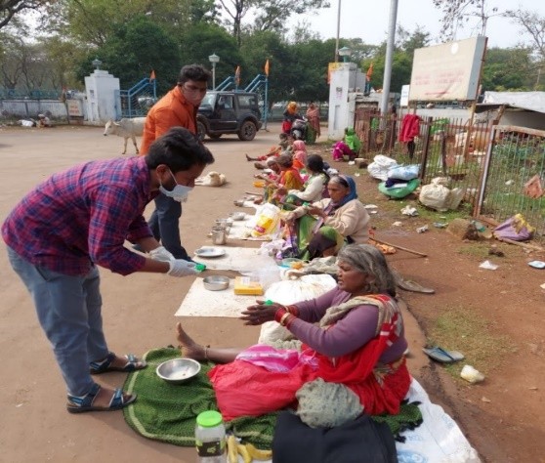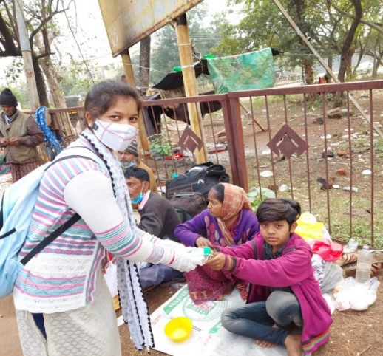
S. No | Name of Participants | S. No | Name of Participants | S. No | Name of Participants
1 | Vandana Xalxo | 6 | Anjal Mary Tirkey | 11 | Kalpana Kujur
2 | Rahul Mahant | 7 | Ankita Ekka | 12 | Vinita Tirkey
3 | Renuka Xalxo | 8 | Deepika Ekka | 13 | Sabita Kujur
4 | Anand Panna | 9 | Dipty Kerketta | 14 | Mukesh Kujur
5 | Amandeep Minj | 10 | Juli Gargai | 15 | Namrata Minj
 |  |  |  | 16 | Roshleen Lakra

Department of Education
Activity Report : 2021-22

Date : 16, January, 2022
Venue : Heritage Public School, Durg
No. of Participants : 07
On 16thJanuary 2022, Community Development Programme was organised by the Department of Education, St.Thomas College,Bhilai .The venue of the programme was Heritage Public School, Durg. The team members collectively planned the venue and planted saplings in Heritage Public School, Durg. The number of beneficiaries were 07 students.

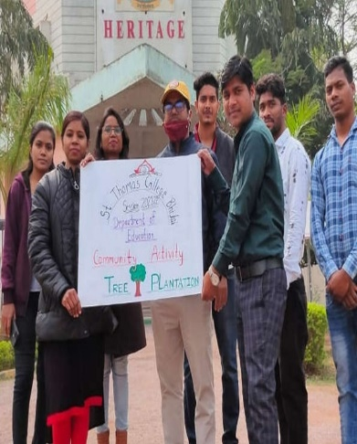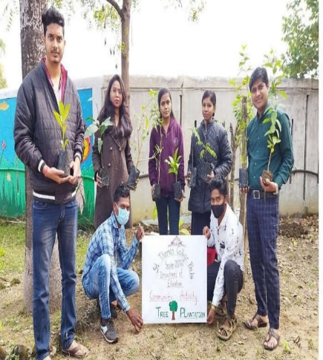
S. No | Name of Participants
1 | Shriparna Yadav
2 | Bahadur Singh
3 | Pratap Kispotta
4 | Preeti
5 | Prakash
6 | Pankaj Lakra
7 | Pratibha Nishad

Department of Education
Activity Report : 2021-22

Date : 16, January, 2022
Venue : Nav Jeevan Girls Hostel Bhanupratappur, Kanker, CG
No. of Participants : 01

On 16thJanuary 2022, as a part of Community Development Programme, Aksa Thomas student of B. Ed, visited Nav Jeevan Girls Hostel Bhanupratappur, Kanker, CG.There were 20 girls from very poor families. This institute is run by charitable and educational trust and it’s a project of New India Evangelistic Association, Bihar. Aksa distributed some colour pencils, drawing papers, mask and some snacks for the children.
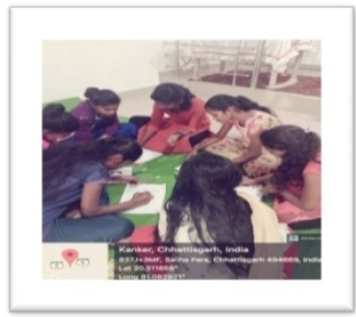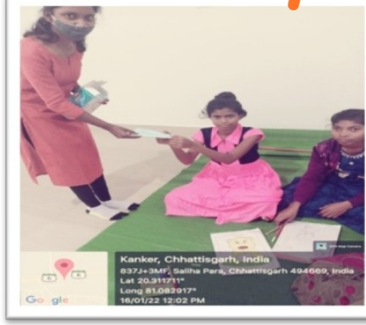

S. No | Name of Participants
1. | Aksa Thomas

Department of Education
Activity Report : 2021-22

Date : 17, January, 2022
Venue : Kansabel, Dist. Jashpur (C.G)
No. of Participants : 02

On 17thJanuary, 2022, as a part of Community Development Programme, Alka Lakra and Binay Bhushan Toppo, Students of B.Ed. Sem-I, rendered their services in a nearby school by cleaning the campus area and surroundings of the school. Collected the garbage of the nearby school surroundings and burnt them and filled mud in the uneven land areas.

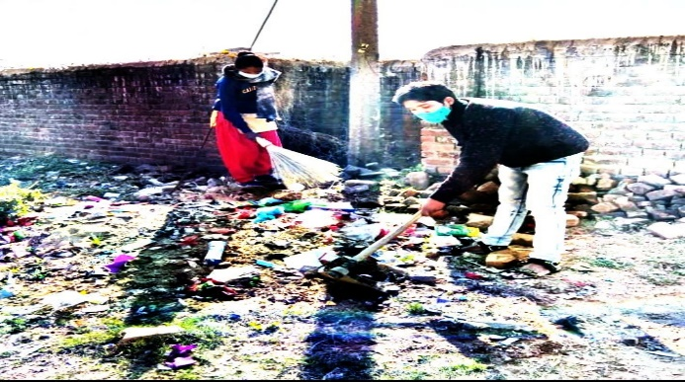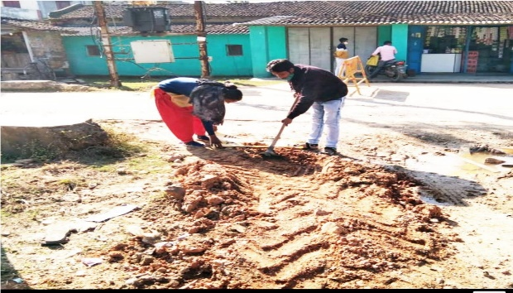

S. No | Name of Participants
1. | Alka Lakra
2. | Binay Bhushan Minj

Department of Education
Activity Report : 2021-22

Date : 17, January, 2022.
Venue : Wisdom Grammar School, Tatapani, CG.
No. of Participants : 02

On 17th January2022, as a part of Community Development Programme, Margret Barwa and Uday Prakash Kerketta students of B.Ed. Sem-I, rendered their services at Wisdom Grammar School, Tatapani by planting saplings, distributing masks to the students and giving awareness classes onCovid-19 protocols and later entertaining them through games.
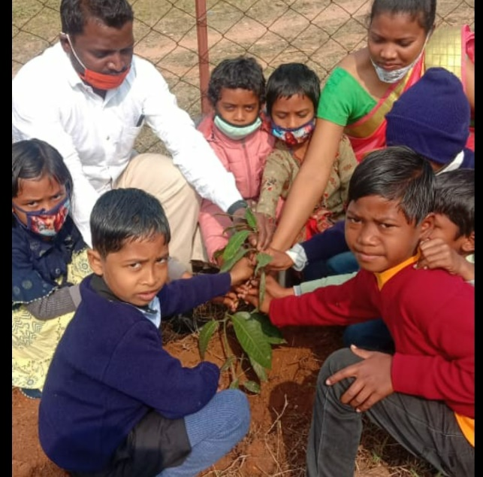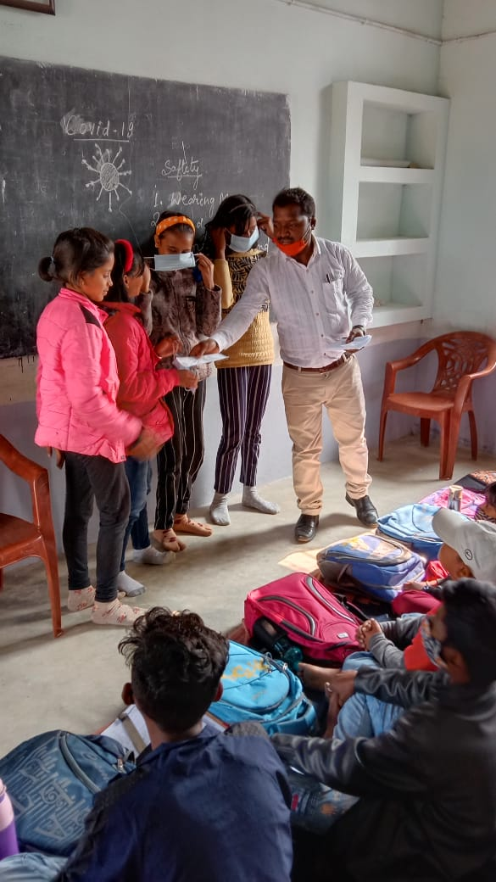

S. No | Name of Participants
1. | Margret Barwa
2. | Uday Prakash Kerkette

Department of Education
Activity Report : 2021-22

Date : 17, January, 2022.
Venue : Kndergarten Public School, Nawadih (Balarampur)
No. of Participants : 02

On 17th January 2022, as a part of Community Development Programme, James Toppo and Salmi Ekka students of B.Ed. Sem-I, rendered their services at Kindergarten Public School, Nawadih (Balarampur) by taking awareness classes to the students of the school and emphasised on the importance of wearing mask and using sanitizer.

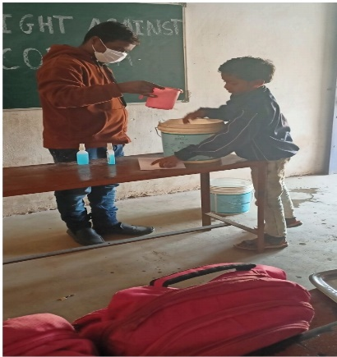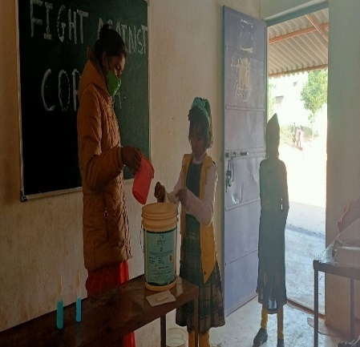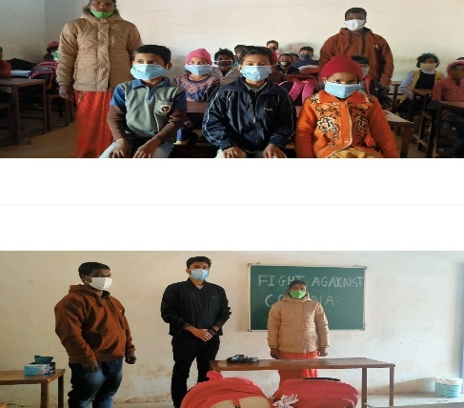

S. No | Name of Participants
1. | James Toppo
2. | Salmi Ekka

Department of Education
Activity Report : 2021-22

Date : 18, January, 2022
Venue : Shri Ganesh Goushala, Ganeri, CG
No. of Participants : 01

On 18th January2022, Community Development Programme was organised by the Department of Education, St.Thomas College,Bhilai. The venue of the programme was ShriGanesh Goushala, Ganeri, CG.Mask distribution and fodder distribution to the workers of Shri Ganesh Goushala was done by Priyanka Yadu. A small sapling was also planted by Priyanka Yadu.

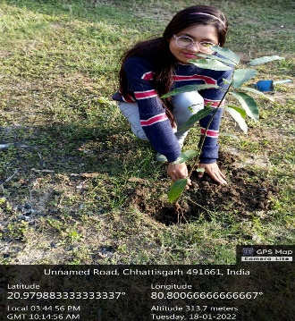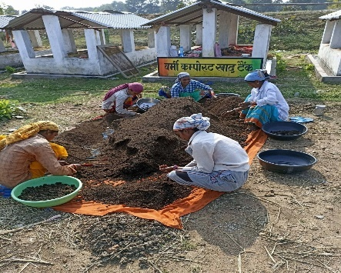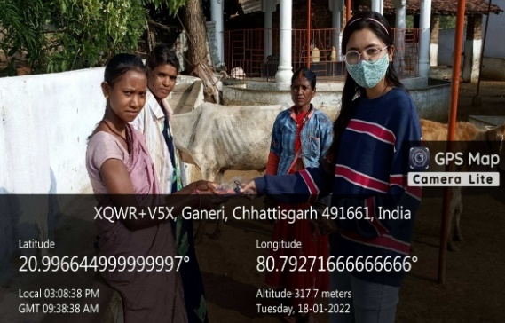

S. No | Name of Participant
1. | Priyanka Yadu

Department of Education
Activity Report : 2021-22

Date : 18, January, 2022
Venue : Azad Market, Risali, Bhilai
No. of Participants : 07

On 18th January,2021, Community Development Programme was organised by the Department of Education, St.Thomas College,Bhilai .The venue of the programme wasAzad Market, Risali, Bhilai. The team of seven members prepared paper bags for the nearby shopkeepers to reduce the use of plastic bags and create an awareness among the shopkeepers to minimize the use of plastic bags in the environment.The number of beneficiaries were 07 students.

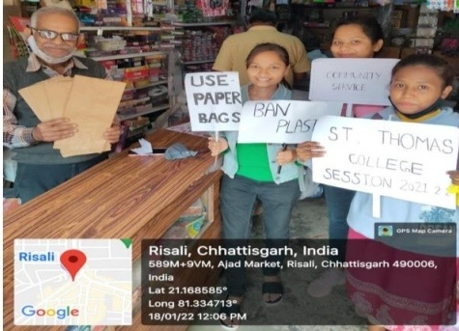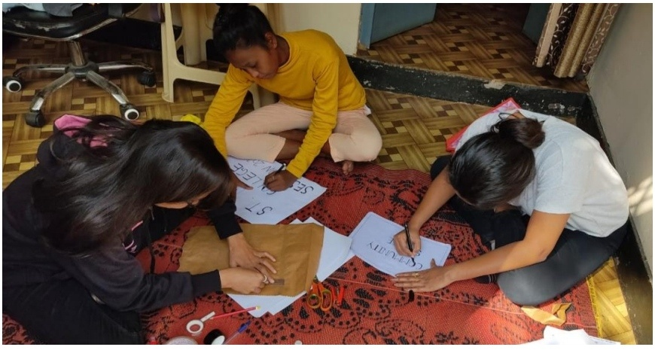
S. No | Name of Participants | S. No | Name of Participants
1 | Jyoti Chandrakar | 5 | Akansha Kaiwart
2 | Rudrani Devi | 6 | Amar Deep Tigga
3 | Sonal Barwa | 7 | Neha Minj
4 | Harshal Jain

Department of Education
Activity Report : 2021-22

Date : 18, January, 2022
Venue : Village Bhadra, Kutrabodh, Pamgarh, Janjgir, CG.
No. of Participants : 01

On 18th January2022, as a part of Community Development Programme Roji Thomas, student of B.Ed, served services to the workers of the school by distributing sanitizers and mask to them. The number of beneficiaries was one student.
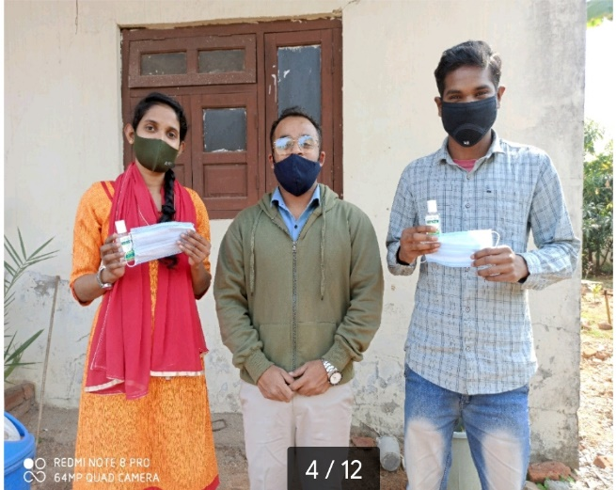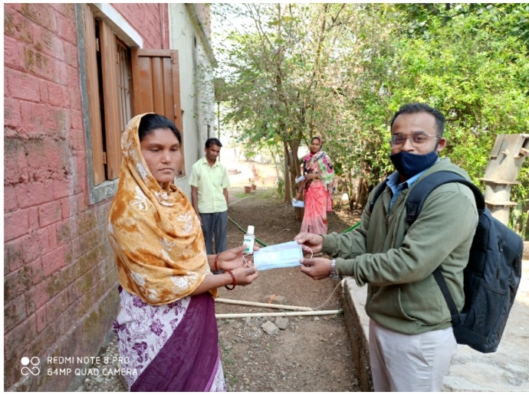

S. No | Name of Participants
1. | Roji Thomas

Department of Education
Activity Report : 2021-22

Date : 18, January, 2022.
Venue : Raghunathpur Jila, Sarguja, CG.
No. of Participants : 01

On 18th January 2022, as a part of Community Development Programme, Asik Toppo, student of B.Ed. Sem-I, planted sapling in his neighbourhood to promote the idea of importance and necessity of planting trees.

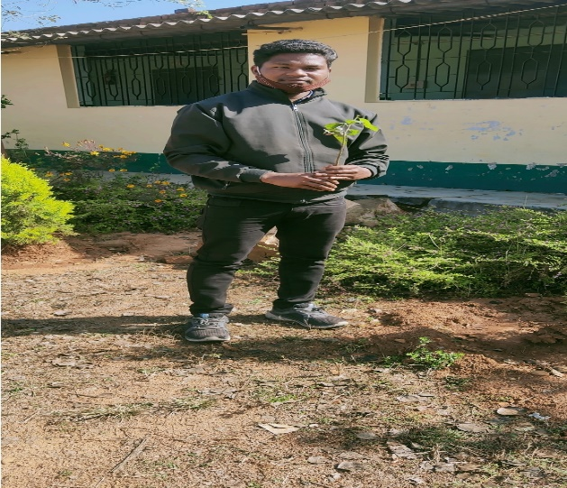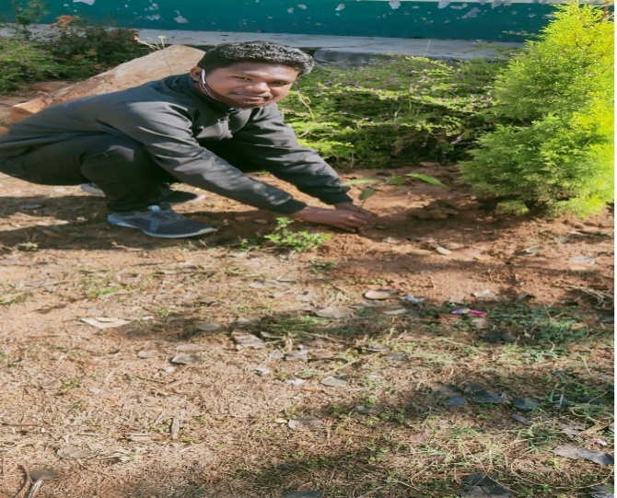

S. No | Name of Participants
1. | Asik Toppo

Department of Education
Activity Report : 2021-22

Date : 20, January, 2022.
Venue : St. John’s EMS Kharsia, Raigarh
No. of Participants : 01

On 20th January 2022, as a part of Community Development Programme, Seema Ekka, student of B.Ed.Sem-I, rendered her services at St. John’s EMS Kharsia, Raigarh by taking awareness classes to students and helping staff regarding current pandemic situations and emphasized on the importance of wearing mask and using sanitizer.

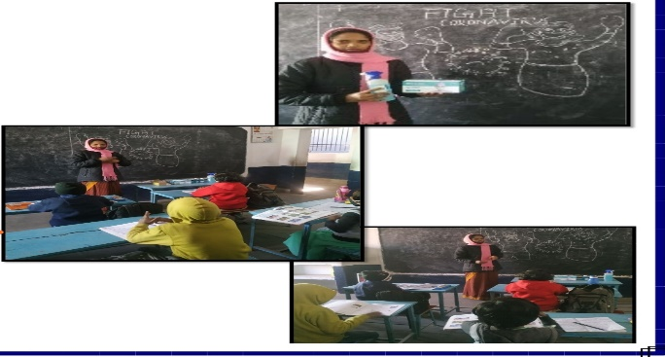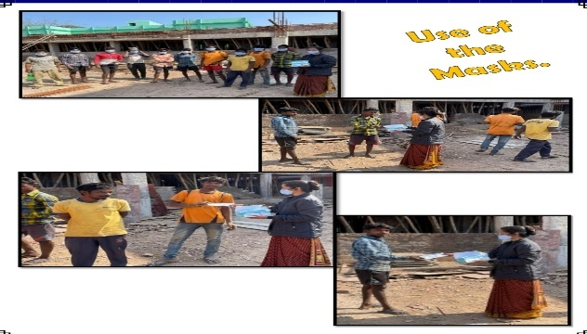

S. No | Name of Participants
1. | Seema Ekka

Department of Education
Activity Report : 2021-22

Date : 22, January, 2022.
Venue : Sai Baba, Higher Secondary National School Chalgali (Balarampur)
No. of Participants : 03

On 22ndJanuary 2022, as a part of Community Development Programme, Amit Raj Bara, Praveen Toppo and Amit Tirkey students of B.Ed. Sem-I, rendered their services by cleaning the school campus and explaining the students about the importance of cleanliness and hygiene. They propagated the slogan “Clean India” to the students.
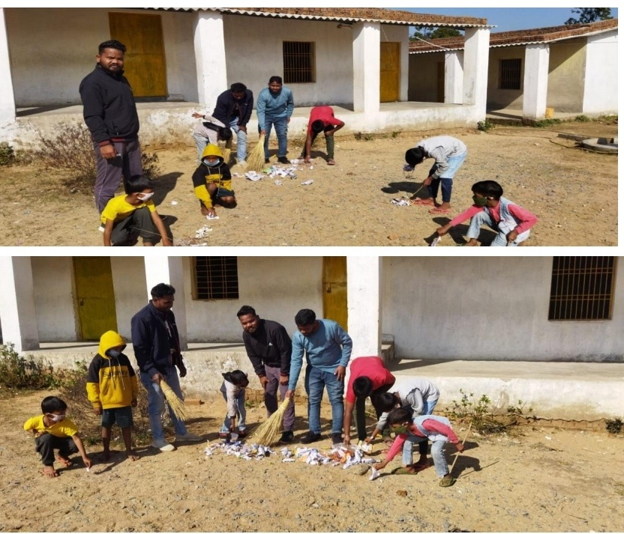
S. No | Name of Participants
1. | Amit Raj Bara
2. | Praveen Toppo
3. | Amit Tirkey

Department of Education
Activity Report : 2021-22

Date : Monday 24th January, 2022.
Venue : Risali, Civic Center, NPA Sector-5
No. of Participants : 01

On 24th January 2022, as a part of Community Development Programme, Rosemary Lakra student of B.Ed. Sem-I, visited several areas of Bhilai like Risali, Civic Center and NPA Sector-5, to feed the stray animals like cows and dogs and tried to sensitize people to take care of them. She herself prepared food for them and very lovingly fed them.

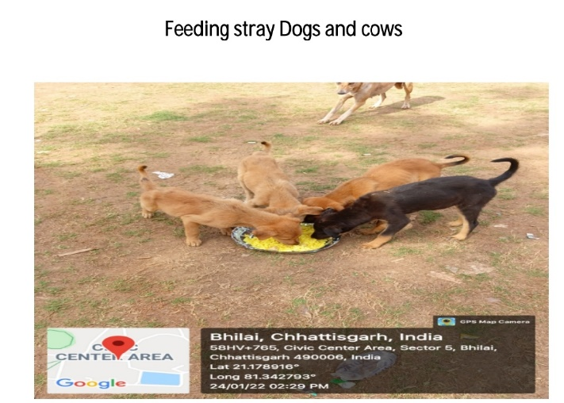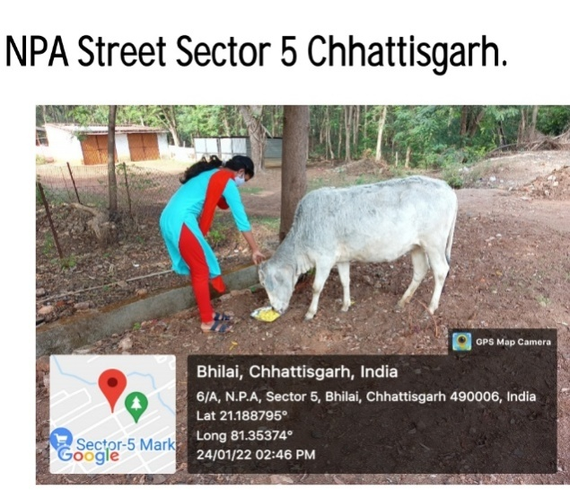

S. No | Name of Participants
1. | Rosemary Lakra

Department of Education
Activity Report : 2021-22

Date : 26, January, 2022
Venue : Atal Aawas, Kanchan Bagh, Lakholi, Rajnandgaon (CG)
No. of Participants : 01

On 26th January 2022, as a part of Community Development Programme, Arpan Samuel Masih student of B.Ed. Sem-I, visited slum area near to his home (2 km). People of that area were living in BPL. He made aware of the pandemic and the protocols and distributed masks and sanitizers.
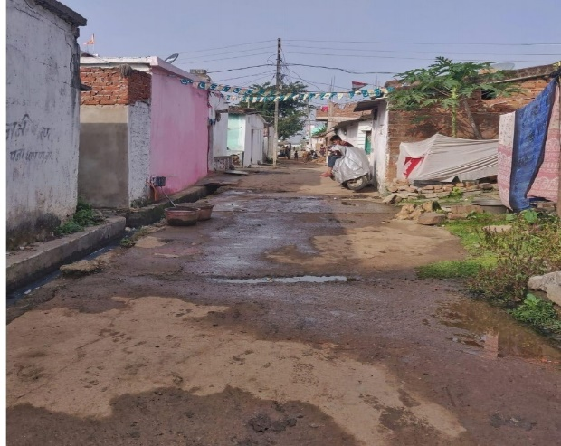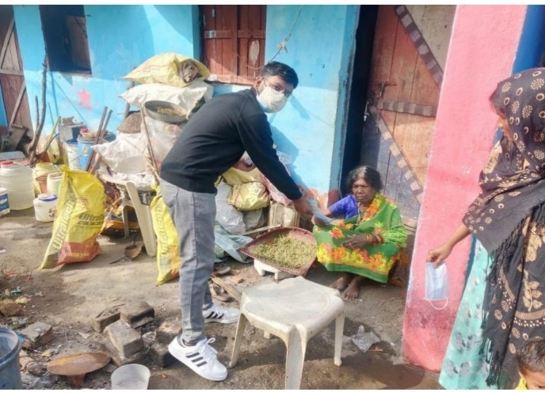

S. No | Name of Partcipants
1. | Arpan Samuel Masih

Department of Education
Activity Report : 2021-22

Date : 27, January, 2022.
Venue : Kutrabod Village, Pamgarh, Janjgir- Champa, CG.
No. of Participants : 01

On 27thJanuary 2022, as a part of Community Development Programme, Jibu James Student of B.Ed. Sem-I, rendered his services to the daily labourers from the nearby village of Kurtabod, Pamgarh by educating them of the importance of using Mask during this time of Pandemic and also distributing masks to them.

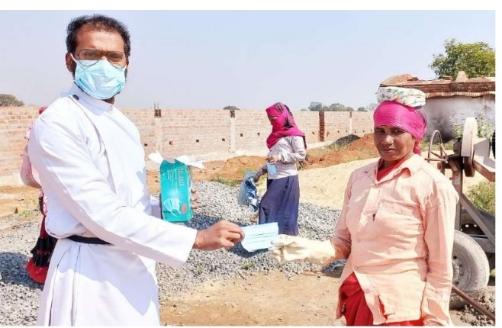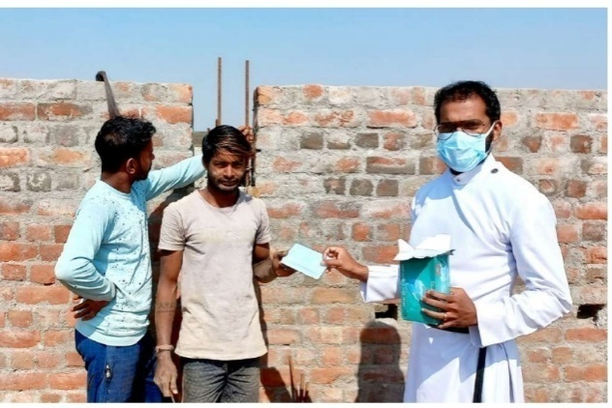

S. No | Name of Participants
1. | Jibu James

Department of Education
Activity Report : 2021-22

Date : 03, February, 2022
Venue : Near the premises of her home Jumaikela,kansabel, Jashpur, CG
No. of Participants : 01

On 3rd January2022, as a part of Community Development Programme, Priscilla Tirkey, Student of B.Ed. Sem-I, rendered her services by planting saplings near the premises of her home in Jashpur. This way such small gesture of Priscilla is encouraging everyone to plant trees for conserving the environment.
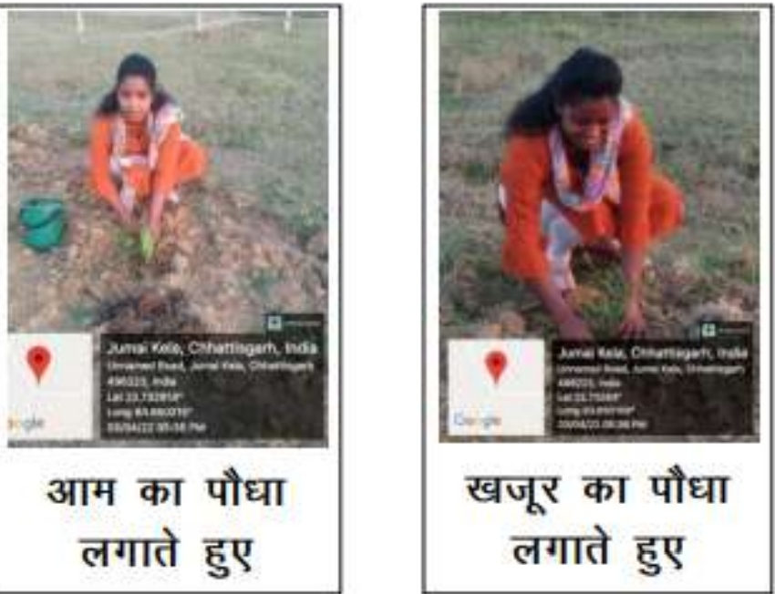

S. No | Name of Participants
1. | Priscilla Tirkey

Department of Education
Activity Report : 2021-22

Date : 10, February, 2022
Venue : Bankheta, Pratappur, Surajpur, CG.
No. of Participants : 01

On 10th February2022, as a part of Community Development Programme, Praveen Toppo, student of B.Ed. Sem-I, rendered his services athis nearby locality and made people aware of the Covid-19 guidelines. He also distributed facemasks to the children of his neighbourhood.

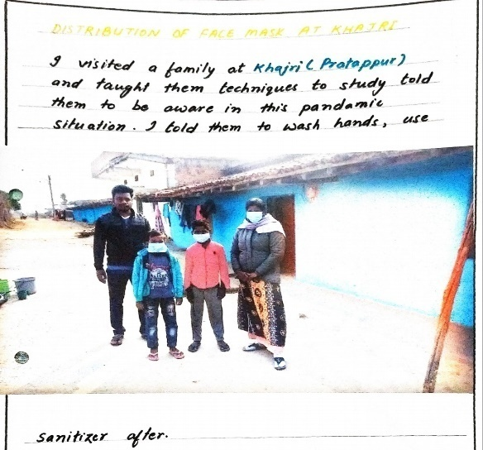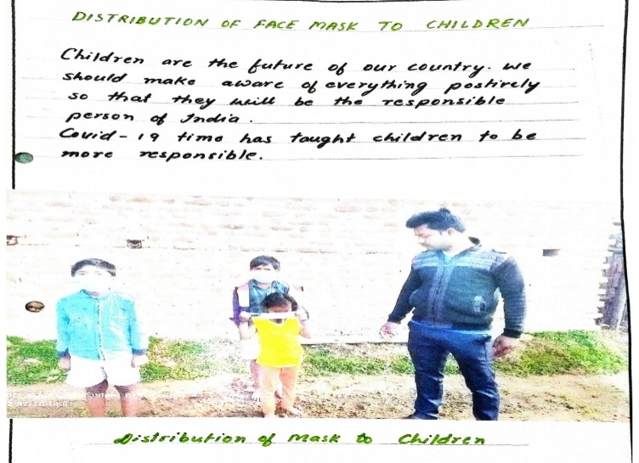

S. No | Name of Participants
1. | Praveen Toppo

Department of Education
Activity Report : 2021-22

Date : 11, February, 2022
Venue : Podi Village, Chattisgarh
No. of Participants : 01

On 27thJanuary 2022, as a part of Community Development Programme, Monu Manjil Tirkey, Student of B.Ed. Sem-I, rendered his services by planting saplings in his nearby area. This way he emphasised on planting trees for conserving the environment through such gestures.

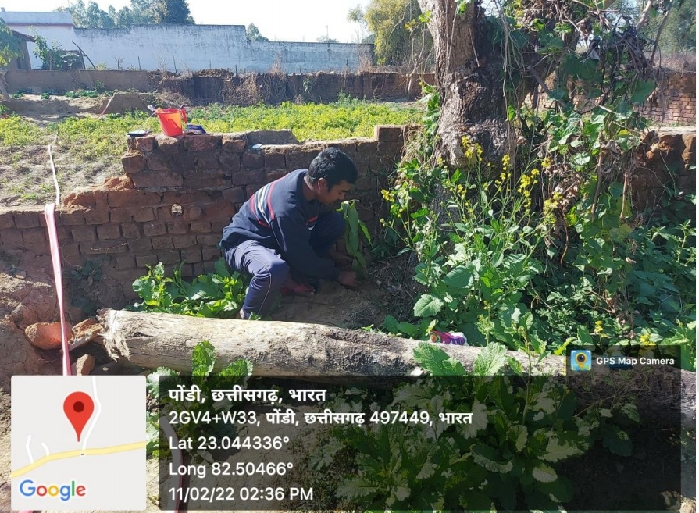

S. No | Name of Participants
1. | Monu Manjil Tirkey

P.G Department of English
Activity Report : 2021-22

Date : 16, March, 2022 to 24, March, 2022
Topic : Seven Day program on knowledge sharing
No. of Participants : 36

The P.G Department of English conducted a holistic development program under the aegis of Aahan - A Knowledge Sharing Initiative by St. Thomas Mission, Bhilai. The program was held in the Government Primary School, Ruabandha. The purpose of the program was to prepare a road map for the primary school students and to furnish their basic skills in English language. Students of MA Sem – II, IV and BA Final rendered their valuable service and actively participated in proper execution of the community service program. The 7 Day program included cursive writing , Phonics drill, Origami and drawing skills to strengthen memory, and improve visualization skills using hands-on learning. 36 students of UG and P.G participated in the community service.

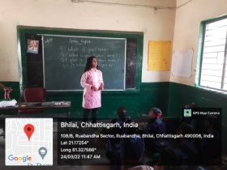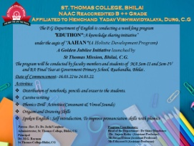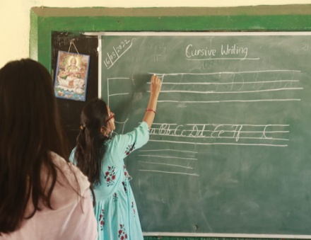

No. of Students Participated : 36

Sl. No. | Name of Participants | Class | Sl.  No. | Name of Participants | Class
1 | Isha Arnold | BA – IIIrd Year | 19 | Lagan Khare | M.A-Sem -II
2 | Hrishil Raipurkar | BA – IIIrd Year | 20 | Pratiksha Mandal | M.A -Sem II
3 | Mehak | BA – IIIrd Year | 21 | Sanjay Deshmukh | M.A-Sem -II
4 | Shruti Giri | BA – IIIrd Year | 22 | Shruti Daniel | M.A -Sem II
5 | Deepshikha | BA – IIIrd Year | 23 | Aastha Ramteke | M.A-Sem -II
6 | Manisha | BA – IIIrd Year | 24 | Shubhang Das | M.A -Sem II
7 | Khushbu | BA – IIIrd Year | 25 | Astha Temurkar | M.A-Sem -II
8 | Prakash | BA – IIIrd Year | 26 | Sakshi Sainik | M.A -Sem IV
9 | Daniel P.U | BA – IIIrd Year | 27 | Garvita Agrawal | M.A-Sem -IV
10 | S.Shweta | BA – IIIrd Year | 28 | Prince Abhishek | M.A -Sem IV
11 | Nimisha | BA – IIIrd Year | 29 | Hemant Dhruv | M.A-Sem -IV
12 | Naveen Daniel | M.A -Sem II | 30 | S. Nirosha | M.A -Sem IV
13 | Bipasha Ray Sokhey | M.A-Sem -II | 31 | Hemant Korram | M.A-Sem -IV
14 | Rimpi Shrivastava | M.A -Sem II | 32 | Pooja Sahu | M.A -Sem IV
15 | Pragya Soni | M.A-Sem -II | 33 | Manjulika Yadav | M.A-Sem -IV
16 | Umang Bajpayee | M.A -Sem II | 34 | Ragini Bhimte | M.A -Sem IV
17 | Anshikha Tripathi | M.A-Sem -II | 35 | Aishwarya Sahu | M.A-Sem -IV
18 | Jyoti Verma | M.A -Sem II | 36 | Abhishek Kumar | M.A -Sem IV

Department of Psychology
Activity Report : 2021 - 22

Date : 29 to 31, March, 2022
Event : Memory Skills, Physical and Mental Health Training
Place : Govt. Primary School, Ruabandha
No. of Participants : 19

The students of Govt. Primary School, Ruabandha, Bhilai were given training on life skills and mental health by the members of the Psychology department. Training on the increase of memory skills, positive physical and mental health and personal hygiene were given. This work was done under the successful guidance of the Head Master of the school and his teachers. Head of the department Dr. Debjani Mukherjee, Assistant Professor Dr. Sumita Singh and Dr. Ankita Deshmukh helped their students to carry out the program. The training was given to the students of classes III to V of Government Primary School. Along with the training, stationery, food items and sanitisers were also distributed to them. The primary school students very enthusiastically participated in all events. These extension programs were also conducted under the aegis of ‘Ahaan’, an initiative of the 50th year celebrations of St. Thomas Mission, Bhilai.

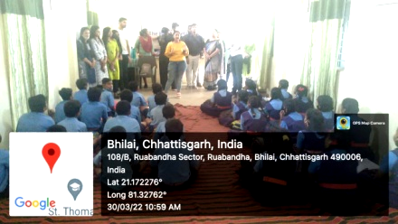

S.no | Name | Class
 | P l Akansha | MA SEM IV
 | G Priyanka | MA SEM IV
 | Sanchana Sahu | MA SEM IV
 | Vanshika Sharma | MA SEM IV
 | Aman Rajput | MA SEM IV
 | Versha Verma | MA SEM IV
 | Mrinalini Barmate | MA SEM IV
 | Jacob P Jossi | MA SEM IV
 | Meghraj Sahu | MA SEM II
 | Praniti Mandavi | MA SEM II
 | Deepak Chandak | MA SEM II
 | Palak Agrawal | MA SEM II
 | Rohan Alex | MA SEM II
 | Riya Maitry | MA SEM II
 | Sudhir Verma | MA SEM II
 | Muskan Gupta | MA SEM II
 | Upasana Verma | MA SEM II
 | Megha Merin Mathew | MA SEM II
 | Shraddha Verma | MA SEM II

Department of Psychology
Activity Report : 2021 - 22

Date : 29, April, 2022
Event : Sarthak Kadam Training on Disabilities and its Interventions
No. of Participants : 13 (STC) + 04 Sarthak Kadam

P.G Dept. of Psychology, St. Thomas College, Bhilai in collaboration with MOU partner Sarthak Kadam Sansthan organized Training Program on Disabilities and Related Therapies. Resource persons of the training program were G. Vanisree and Anuradha V, faculty in Sarthak Kadam Sansthan, Sector-10, Bhilai. G. Vani and Anuradha V both introduced the budding psychologists of St. Thomas College to their students. In their briefing they informed the P.G students that Sarthak Kadam has inmates who are suffering from autism, down syndrome, mental retardation, ADHD and cerebral palsy.

The speakers further elaborated that the Institution is established to fulfil the needs of special children. Various sensory- motor training for example Fine & Gross Motor Skills Training and Behavioural Training is given to these Special children. The various Therapeutic Models, Instruments and Tests were also introduced to the students. Students were given detailed description of questionnaires and to use them to identify the mental defects. Strategies used when children show reluctance in coping or behaviour malfunction were demonstrated. The students were guided to understand how to create a stimulating environment for the special needs.

No. of Students Participated : 13

S.No | Name of Participants | Class
 | G. Priyanka | M A Sem IV
 | Jacob Jossi | M A Sem IV
 | Rohan Alex | M A Sem II
 | Deepak Chandak | M A Sem II
 | Sudhir Verma | M A Sem II
 | Palak Agrawal | M A Sem II
 | Riya Maitry | M A Sem II
 | Muskaan Gupta | M A Sem II
 | Megha Merin | M A Sem II
 | Sambodhi | M A Sem II
 | Shraddha Verma | M A Sem II
 | Upasana | M A Sem II
 | Praniti | M A Sem II

